**PROJECT PROPOSAL**

**Project Name:** Movie Guide

**Team Members:** Durga Prasad Kallem

Rakesh Avirineni

Susritha Gade

**Aim:**

This app helps the one who wants to watch a best movie. This app consists the list of recent movies, rating from critics and audience, general opinion and short overview about the movie.

**Overview:**

* Initially after opening the app, user will be directed to the page where a list of movies are displayed named as top rated, popular movies.
* Then user selects the movie.
* Rating, General opinion and Short Overview about the movie are displayed when movie is selected.
* If the user wants they can save the movie to favorites.

**Activities:**

When app is opened, it displays the page with the list of movies.

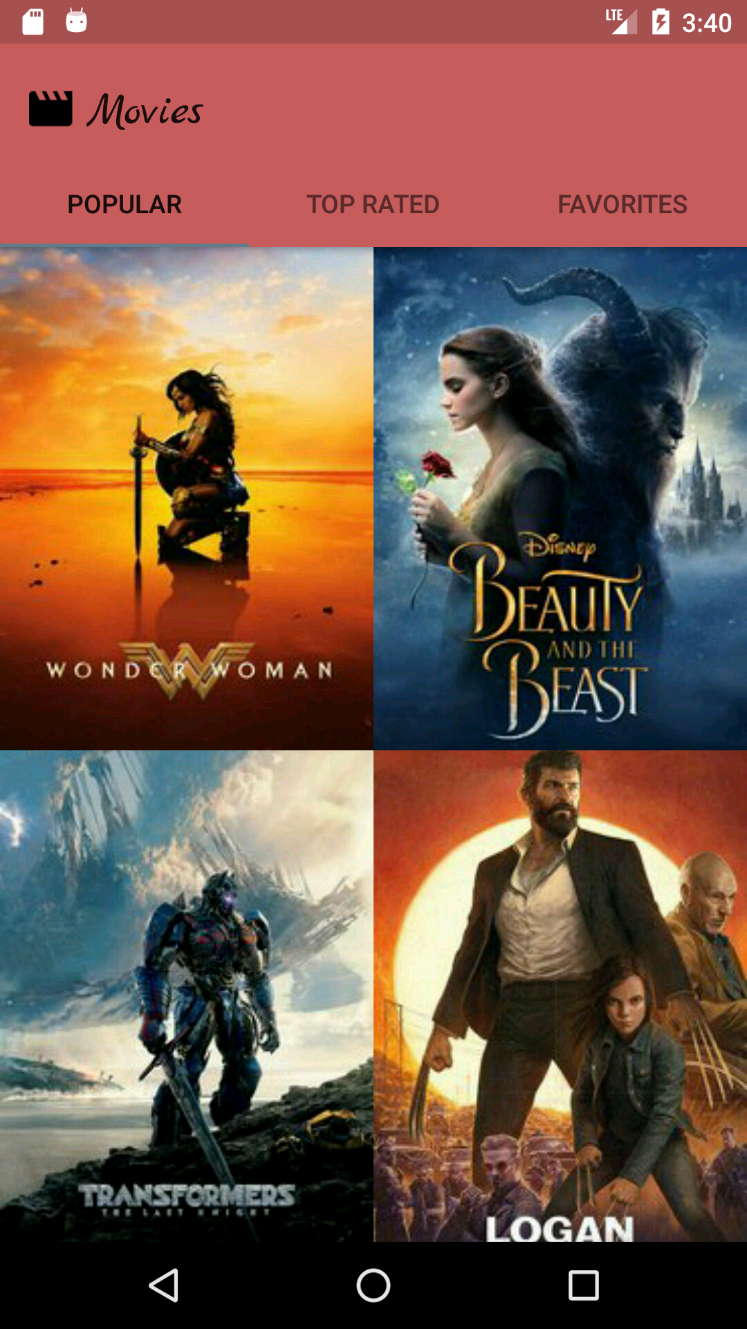

* When user clicks on particular movie they want to know about it will display rating from critics and audience, general opinion and Short Overview.
* User can watch the trailer of the movie. If user click on the video it will be redirected to movie.
* He can add it to favorites by clicking on the symbol that is present in bottom right of the page.

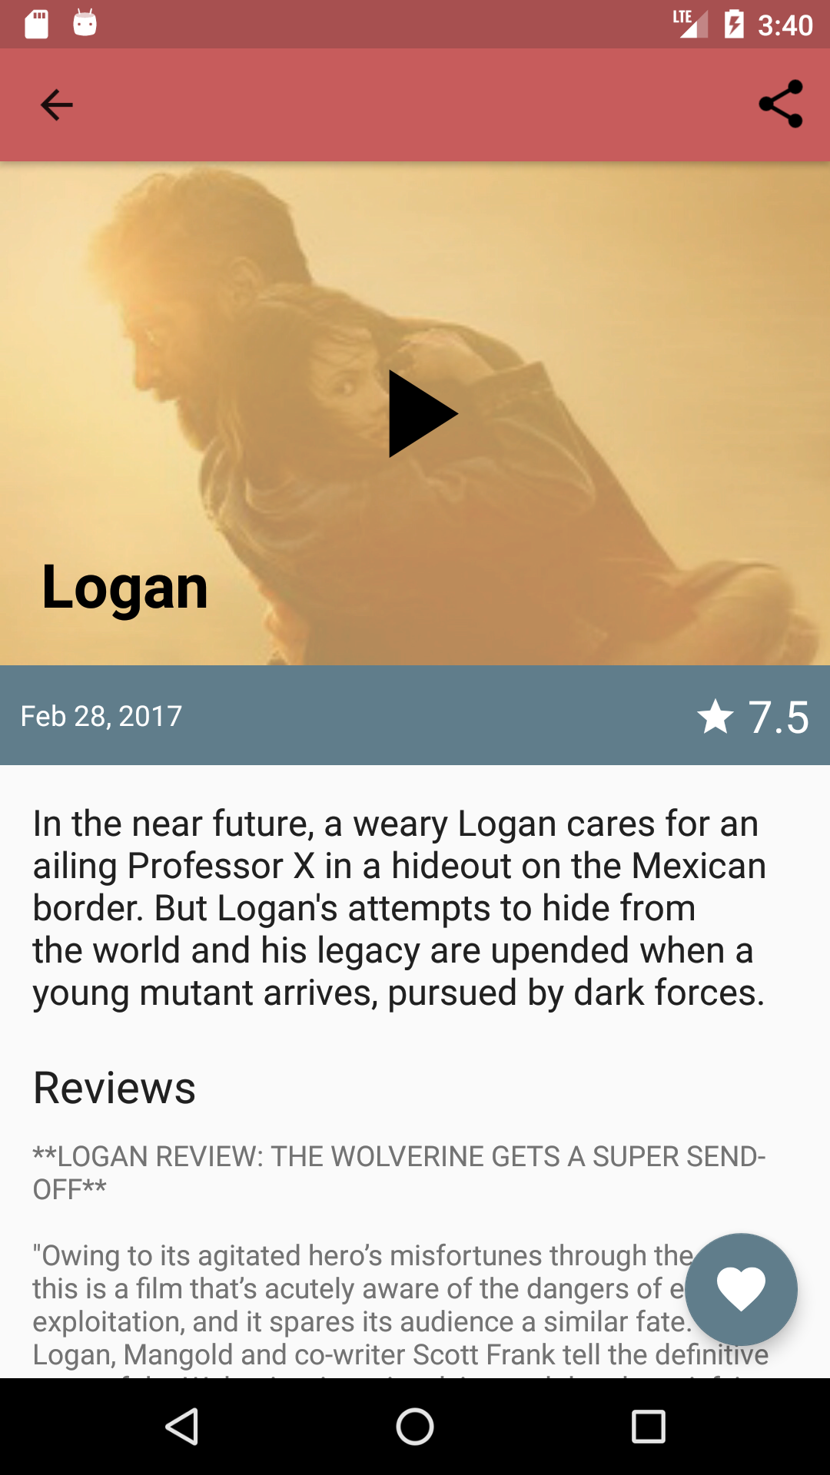

* We have used The Movie Database API.

This is our “ER Diagram”

